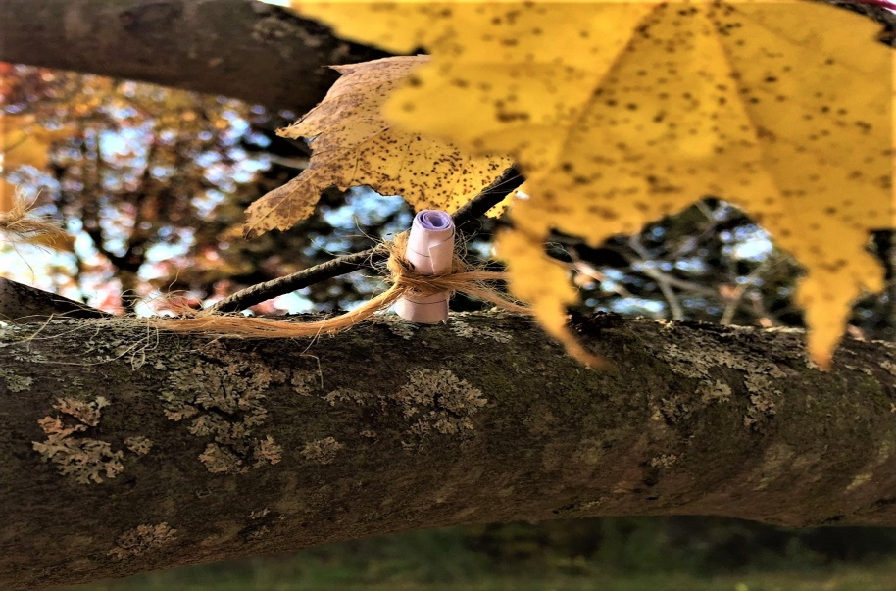

Forest Therapy Walk
November 3, 2018
Come experience a walk in the woods like no other, this is not a nature walk, not an herb walk, and not a power walk. It is a walk that will saturate your senses to recharge, ground, and connect you to the healing power of Nature. Tuning into all of your senses is the best way to experience the Spirit of Place, and also relax into the sacred awareness of your authentic self. This transition time of Fall into Winter here in Michigan has much to share with us.
Join Minnie Kansman, a certified Forest Therapy Guide, on gentle paths in the woods in her own backyard. Minnie will invite you through guided sensory activities to experience your own Nature Connection. These invitations will assist you to explore Nature in the deepest way possible. This may take the form of healing, relaxing, or just slowing down to honor the shifting seasons surrounding us. We will finish our day drinking hot wild gathered herbal tea and sharing your experiences around an open fire to keep us warm.
Bring: Bottle of water or warm beverage, food to snack on, a waterproof tarp or blanket to sit on, or portable camp chair if sitting on the ground is difficult for you. Dress in layers for the weather, bringing one more layer that you think is necessary. Hats, gloves and warm shoes are recommended for this time of year, even a blanket as you want to be as comfortable as possible. We will meet at my home in Lyons, MI. Please arrive here 15 minutes before our walk begins at 1PM at the Fire pit.

Where: 4287 Lyons Rd. Lyons, Michigan.
Date: Sunday afternoon on November 3, 2018
Time: 1 pm – 4 pm
Cost: $33 each class
Contact Minnie: 616. 550. 4088
Mail payment before class or on site the day of class.
Minnie Kansman
4287 Lyons Rd
Lyons, Mi 48851

Ages 8-88 + We will be walking on a uneven leaf covered surfaces in the woods. There is a shelter shack to sit in to keep out of the wind if necessary. There will also be many opportunities to be silent during this workshop.

